**LED STRING ANIMATION PO5_LSAN**

Project Description:

Strings of LEDs as the following structure are used to provide Tail and TI functions based on some input signals.

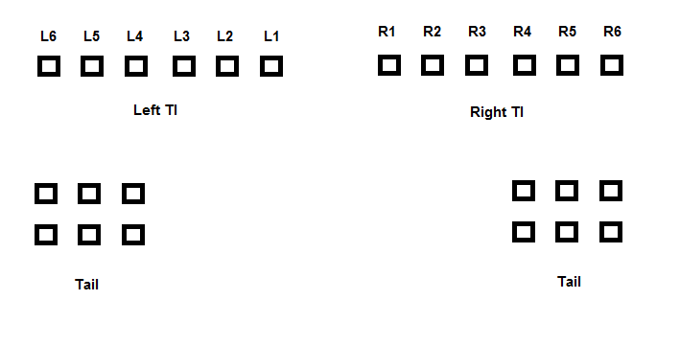Requirements Description:

- At startup, WELCOME mode shall be one of the following modes:

* **First mode**: LEDs shall be ON from L6 to L1, then from R1 to R6 and vice versa, and then all LEDs are ON and OFF.
* **Second mode**: LEDS from R1 to R6 are ON LED by LED and also the left branch at the same time, and then repeat the scenario again.

- Tail function shall be activated according to Tail switch.

- TI function shall be activated be activated according to TI switch, LEDs shall be activated LED by LED from R1 to R6 or from L1 to L6.